**Summer Internship Report**



In the field of

**Internet of Things**

**And**

**Artificial Intelligence**

Submitted By-

**Nikhil Ayalane**

**16csu226**

**Table of Contents**

1. Introduction………………………………………........04
2. Project Design…………………………………….........05
3. Functions done in this project.........................................05
4. Tools and Technology used in this project.....................06
5. ARDUINO CODE..........................................................10
6. Screenshots.....................................................................15
7. Conclusion......................................................................19

**List of Figures**

Figure 1 NodeMCU Development Board/kit v1.0 (Version2).....................06

Figure 2 CIRCUIT DIAGRAM...................................................................06

Figure 3 Grove - Gas Sensor(MQ2)..............................................................07

Figure 4 Servo motor...................................................................................07

Figure 5 Arduino IDE..................................................................................08

Figure 6 ThingSpeak Cloud.................................................................09

Figure 7 THE PROJECT SETUP

7.1) FIG. 1....................................................................................15

7.2) FIG. 2....................................................................................15

Figure 8 ARDUINO OUTPUT............................................................16

Figure 9 ARDUINO HTML LINKED PAGE OUTPUT........................16

Figure 10 THINGSPEAK OUTPUT FIELD CHART GRAPHS

10.1) FIG. 1...........................................................................17

10.2) FIG. 2...........................................................................17

10.3) FIG. 3...........................................................................18

Figure 11 DATA VISUALISATION ON ARDUINO OUTPUT

11.1) FIG. 1..........................................................................18

11.2) FIG. 2..........................................................................19

11.3) FIG. 3..........................................................................19

**Abstract**

The Training was carried out at The Northcap University, Gurugram, during the period of 26th May 2019 to 10th July 2019.

The internship was purely aimed at acquiring knowledge and skills necessary to successfully perform a particular job or task.

This includes changes in specific areas of knowledge, abilities, skills, behavior and even attitude towards other colleagues in order to prepare for better job performances. The internship was a great experience has framed me better both in terms of my technical knowledge as well as personal growth.

The internship begin on 26th May. Dr. Shriram K. Vasudevan was my mentor for my internship period. I was mainly assigned to make a project based on IoT and also must include AI in the project. I was supposed to build small model so that they could understand the implementation of the modules and technologies and hence start working on them.

A lot of challenges and dead ends were observed during tenure of the internship, however I learned an important lesson that there always is an solution. As a result, all the tasks assigned to me were completed successfully and on time and results were completely up to the mark.

1. **Introduction**

It has been observed that in industrially developing or developed countries human health get majorly affected due to Air Pollution, where there is no infrastructure to monitor it or keep it under control. In recent researches it has been proven that there is a high correlation between atmospheric pollutants and diseases like asthma and lung related diseases. Air pollution is now a major concern across the globe and World Health Organization (WHO) has developed certain guidelines to restrict the limits of certain gases like Ozone (O3), Nitrogen Dioxide (NO2), Sulphur Dioxide (SO2). The Air Quality Index calculation and pollution monitoring are mainly done Air Quality monitoring (AQM) stations that are pretty much precise and accurate. They exhibit optimum reliability and effective in measuring a wide range of air pollutants. But even after all these stations lag mainly in three areas:

1) Infrastructure, necessary for installation because of the huge size, 2) Operational requirements are pretty much complex, 3) The recurring expenses of setting up, daily maintenance and calibration.

As a result of these flaws, the numbers of installations are less and eventually lead to discrete AQM Networks with limited air pollution data to collect. The recent advancements in embedded electronics have enabled the usage of wireless network technologies in monitoring different real-time sensor data, like temperature, pressure and air pollution. The data retrieved by the devices are sent wirelessly to a database on a remote server for future analysis and processing.

1. **Project Design**

IoT mainly deals with connecting smart devices (embedded electronics devices) to internet by harnessing the advantage of OSI layered Architecture. In the context of this work we propose a cluster of Air Quality Monitoring Sensor motes, which are used to measure the concentration of Air pollutants in the air. All the Air Sensors are interfaces with a tiny embedded platform equipped with network connectivity and are interconnected to internet making it a global network of connected things. So this is basically a complete IoT + AI based Application which includes hardware part as well as software part. We have mainly used the NodeMCU which is an open source development boards with ESP8266-12E chips. MQ-2 Gas Sensor is used to collect gas concentration measurements. This sensor data would be captured and sent to the ThingSpeak cloud for IoT based data acquisition.

**Functions done in this project**

1) The NodeMCU is set inside the breadboard.

2) Gas Sensor Connection:

a) Vcc is connected to Vin port of the NodeMCU.

b) GND is connected to the GND pin of NodeMCU

c) A0 pin is connected to the A0 pin of the NodeMCU

3) Servo Motor Connection

a) +ve pin of Servo Motor is connected to Vin of NodeMCU

b) -ve pin is connected to the GND of NodeMCU

c) The actuator pin or the output pin is connected to the D0 pin of NodeMCU.

4) LEDs Connection

a) The +ve pins of the LEDs are connected to the Vin port of the NodeMCU and the -ve

pins to the GND of the NodeMCU

**CIRCUIT DIAGRAM**

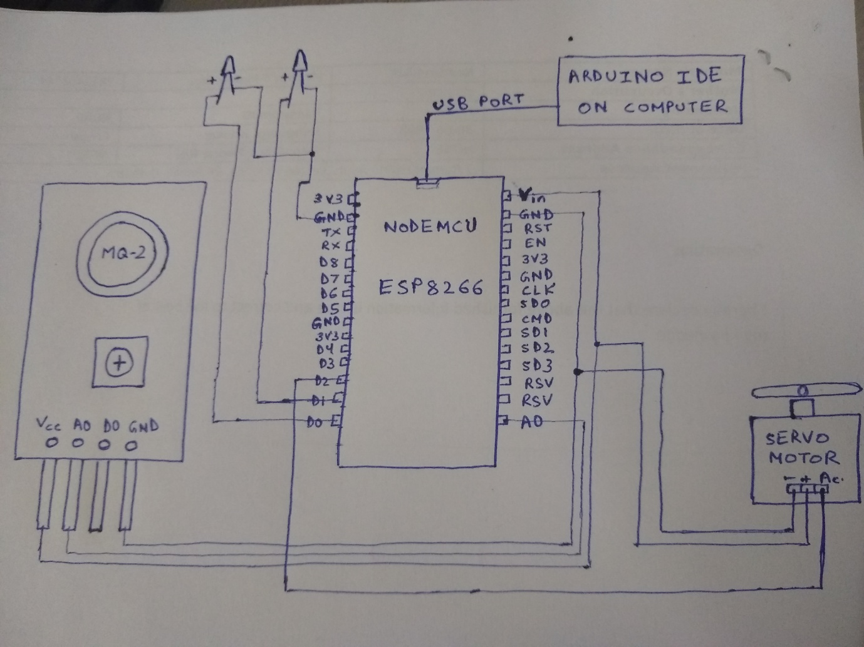

**Tools and Technology used in this project**

**HARDWARE:**

NodeMCU, MQ2 Gas Sensor, Servo motor, LEDs, wires, breadboard

**SOFTWARE:**

Arduino IDE installed in you PC / Laptop, Jupyter Notebook, Python & different libraries, ThingSpeak cloud

**Hardware:**

1. **NodeMCU**

NodeMCU is an open source LUA based firmware developed for ESP8266 wifi chip. By exploring functionality with ESP8266 chip, NodeMCU firmware comes with ESP8266 Development board/kit i.e. NodeMCU Development board. Since NodeMCU is open source platform, their hardware design is open for edit/modify/build. NodeMCU Dev Kit/board consist of ESP8266 wifi enabled chip. The **ESP8266** is a low-cost Wi-Fi chip developed by Espressif Systems with TCP/IP protocol.

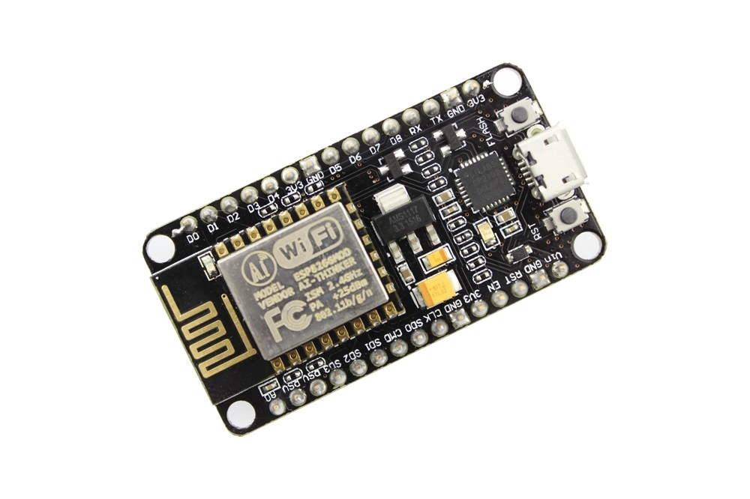

**NodeMCU Development Board/kit v1.0 (Version2)**

1. **MQ2 Gas Sensor**

The Grove - Gas Sensor(MQ2) module is useful for gas leakage detection (home and industry). It is suitable for detecting H2, LPG, CH4, CO, Alcohol, Smoke or Propane. Due to its high sensitivity and fast response time, measurement can be taken as soon as possible. The sensitivity of the sensor can be adjusted by potentiometer.

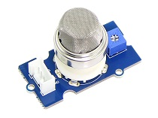

**Grove - Gas Sensor(MQ2)**

The MQ-2 sensor has 4 pins.

|  |  |
| --- | --- |
| **Pin** | **Wiring to Arduino Uno** |
| A0 | Analog pins |
| D0 | Digital pins |
| GND | GND |
| VCC | 5V |

1. **Servo motor**

A servomotor is a [rotary actuator](https://en.wikipedia.org/wiki/Rotary_actuator) or [linear actuator](https://en.wikipedia.org/wiki/Linear_actuator) that allows for precise control of angular or linear position, velocity and acceleration. It consists of a suitable motor coupled to a sensor for position feedback. Servomotors are used in applications such as [robotics](https://en.wikipedia.org/wiki/Robotics), [CNC machinery](https://en.wikipedia.org/wiki/CNC_machine) or [automated manufacturing](https://en.wikipedia.org/wiki/Automated_manufacturing).

[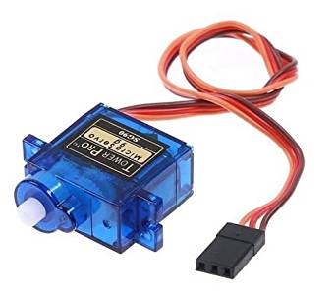](https://www.google.com/url?sa=i&rct=j&q=&esrc=s&source=images&cd=&ved=2ahUKEwjlqbras4fjAhWHqo8KHdBBC1sQjRx6BAgBEAU&url=https://www.amazon.in/Robodo-Electronics-Tower-Micro-Servo/dp/B00MTFFAE0&psig=AOvVaw2r6mwXcS4e-IGgXMiSpPAp&ust=1561647287874362)

**Software:**

1. **Arduino IDE** installed in your PC / Laptop

[Arduino](http://arduino.cc/) is an open-source platform used for building electronics projects. Arduino consists of both a physical programmable circuit board (often referred to as a [microcontroller](http://en.wikipedia.org/wiki/Microcontroller)) and a piece of [software](http://arduino.cc/en/Main/Software), or IDE (Integrated Development Environment) that runs on your computer, used to write and upload computer code to the physical board.

The **Arduino** integrated development environment (**IDE**) is a cross-platform application (for Windows, macOS, Linux) that is written in the programming language Java.

[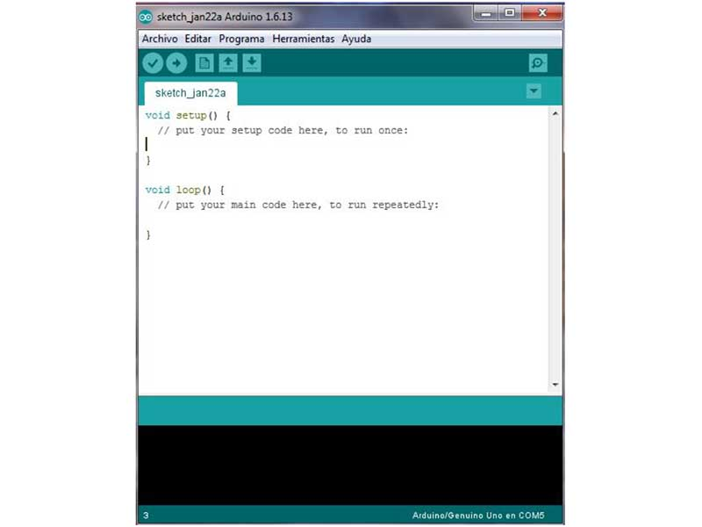](https://www.google.com/url?sa=i&rct=j&q=&esrc=s&source=images&cd=&ved=2ahUKEwjs35T-iYnjAhUdTI8KHfIoA68QjRx6BAgBEAU&url=https://www.digikey.com/en/maker/blogs/2018/introduction-to-the-arduino-ide&psig=AOvVaw248iWPO18OdTymLTgdAqd1&ust=1561704815327094)

**Arduino IDE**

5) **Jupyter Notebook, Python & different libraries**

6) **ThingSpeak cloud**

**ThingSpeak** is an Internet of Things (IoT) platform that lets you collect and store sensor data in the cloud and develop IoT applications. The ThingSpeak IoT platform provides apps that let you analyze and visualize your data in MATLAB, and then act on the data.

[](https://www.google.com/url?sa=i&rct=j&q=&esrc=s&source=images&cd=&ved=2ahUKEwj6juyejYnjAhWDOI8KHc_CBnEQjRx6BAgBEAU&url=http://nothans.com/measure-wi-fi-signal-levels-with-the-esp8266-and-thingspeak&psig=AOvVaw2CmRi8R7d5HgpxEsRWt5tM&ust=1561705439859781)

**ARDUINO CODE**

#include <ESP8266WiFi.h>

#include <WiFiClient.h>

#include <ThingSpeak.h>

#include<Servo.h>

#include <ESP8266WebServer.h>

Servo servo_test;

int gas = A0;

int angle = 0;

const char* ssid = "Parth";

const char* password = "saumya*parth";

WiFiClient client;

unsigned long myChannelNumber = 806388;

const char * myWriteAPIKey = "7Z7Z33GN8DIPDSOR";

ESP8266WebServer server(80);

String webpage = "";

void setup()

{

pinMode(D0,OUTPUT);

pinMode(D1,OUTPUT);

pinMode(gas,INPUT);

servo_test.attach(D2);

Serial.begin(115200);

delay(10);

// Connect to WiFi network

Serial.println();

Serial.println();

Serial.print("Connecting to ");

Serial.println(ssid);

WiFi.begin(ssid, password);

while (WiFi.status() != WL_CONNECTED)

{

delay(500);

Serial.print(".");

}

Serial.println("");

Serial.println("WiFi connected");

// Print the IP address

Serial.println(WiFi.localIP());

ThingSpeak.begin(client);

}

void loop()

{

static boolean data_state = true;

int sensorValue = analogRead(gas);

float a = sensorValue*(5.0/1023.0);

/* The sensor can measure concentrations of flammable gas from 300 to 10,000 ppm.

Assume min. sensorValue around 400ppm below which its fresh air. */

if(sensorValue > 420)

{

Serial.println("uploaded");

digitalWrite(D1,LOW);

digitalWrite(D0,HIGH);

for(angle = 0; angle < 180; angle += 1) // command to move from 0 degrees to 180 degrees

{

servo_test.write(angle); // command to rotate the servo to the specified angle

delay(15);

}

}

else

{

Serial.println("uploaded");

digitalWrite(D0,LOW);

digitalWrite(D1,HIGH);

for(angle = 180; angle > 0; angle -= 1)

{

servo_test.write(angle);

delay(15);

}

}

ThingSpeak.writeField(myChannelNumber, 2,a , myWriteAPIKey);

webpage = "<link rel=\"stylesheet\" href=\"https://maxcdn.bootstrapcdn.com/bootstrap/3.4.0/css/bootstrap.min.css\">";

webpage += "<script src=\"https://maxcdn.bootstrapcdn.com/bootstrap/3.4.0/js/bootstrap.min.js\"></script>";

webpage += "<h1>IOT Air Pollution Monitoring System</h1>";

webpage += "<br><br><br><h2>";

webpage += " Air Quality is ";

webpage += sensorValue;

webpage +=" PPM";

webpage += "<br><br>";

webpage += " a = ";

webpage += a;

webpage += "<br><br>";

if (sensorValue<420)

{

webpage += "Fresh Air";

}

else if(sensorValue>420 && sensorValue<500)

{

webpage += "Average Air";

}

else

{

webpage += "Poor Air";

}

webpage += "<br><br>";

webpage += "<form action=\"\"><button class=\"btn btn-lg btn-info\">CHECK CURRENT POLLUTION LEVEL</button></form>";

webpage += "</h2></p></body>";

server.on("/", [](){

server.send(200, "text/html", webpage);

});

server.begin();

Serial.println("\nWeb server started!");

server.handleClient();

Serial.println(sensorValue);

Serial.println(a);

delay(1000);

// Write to ThingSpeak. There are up to 8 fields in a channel, allowing you to store up to 8 different

// pieces of information in a channel. Here, we write to field 1.

delay(1000); // ThingSpeak will only accept updates every 1 second.

}

**SCREENSHOTS**

**THE PROJECT SETUP**

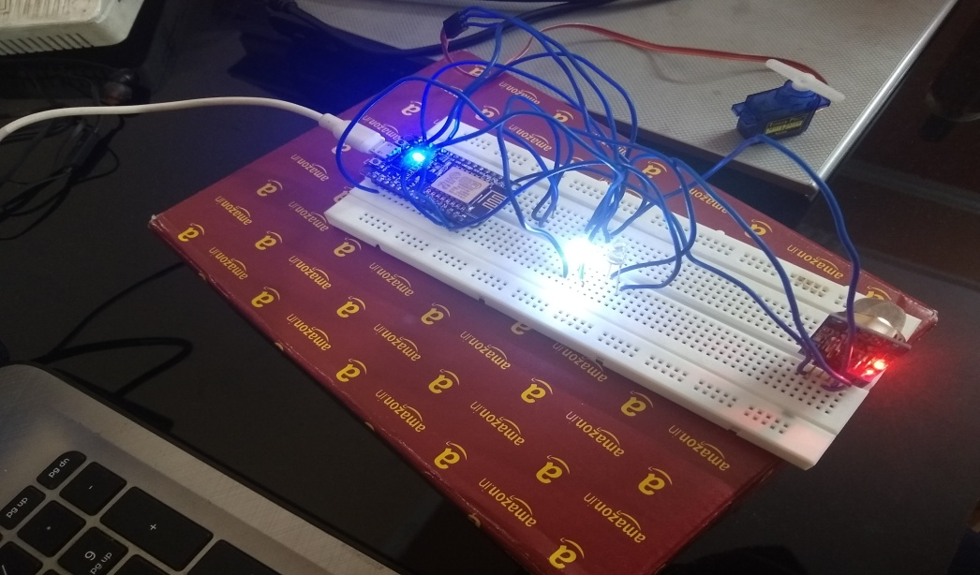

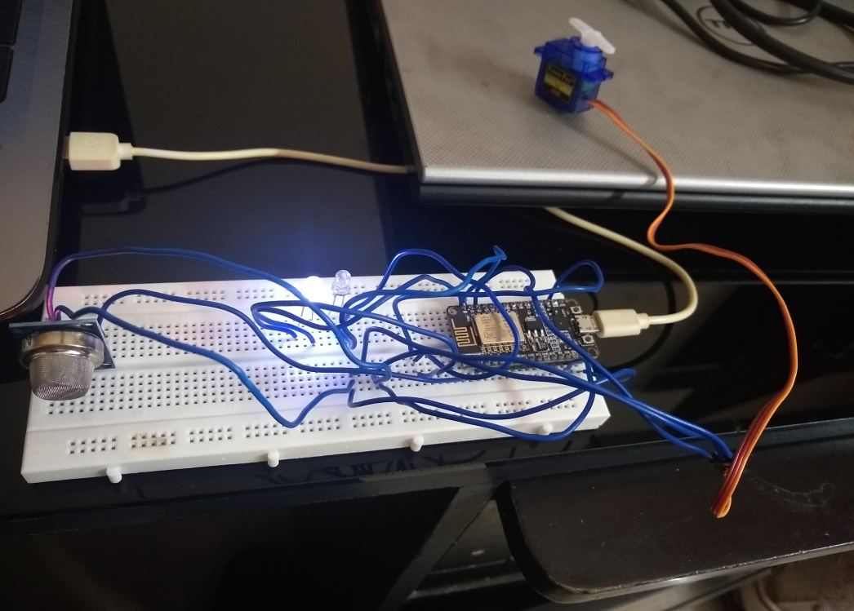

**ARDUINO OUTPUT**

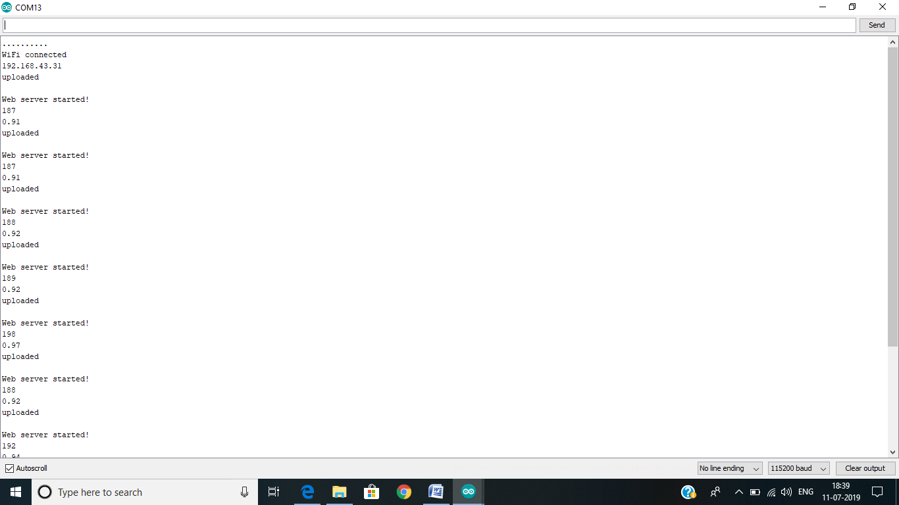

**ARDUINO HTML LINKED PAGE OUTPUT**

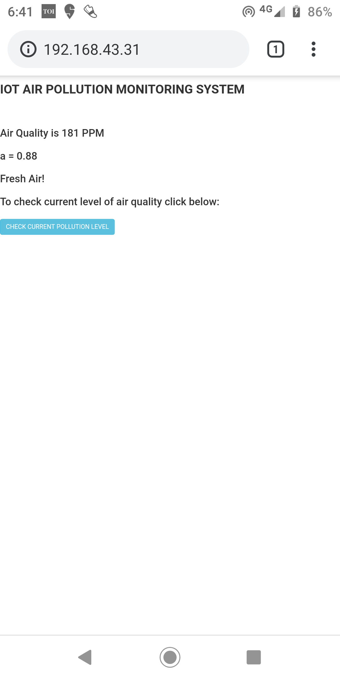

**THINGSPEAK OUTPUT FIELD CHART GRAPHS**

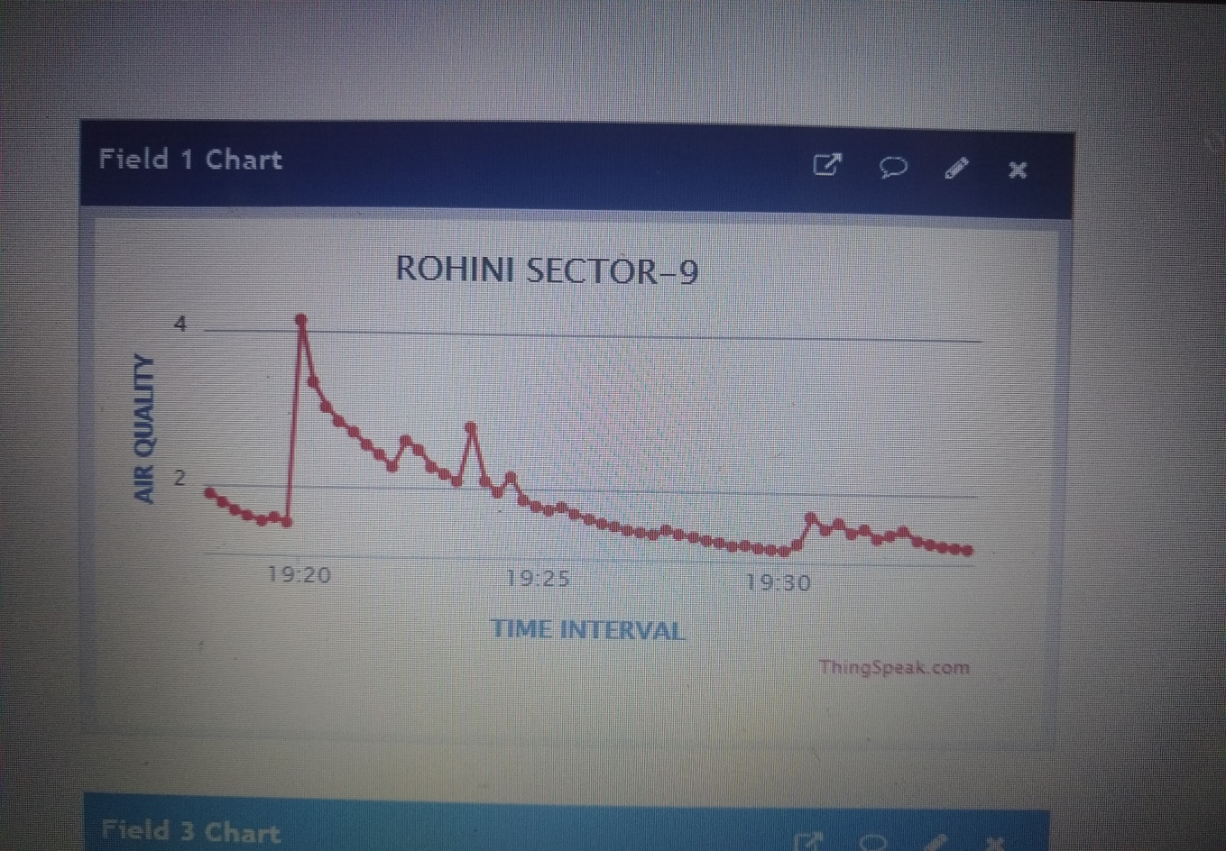

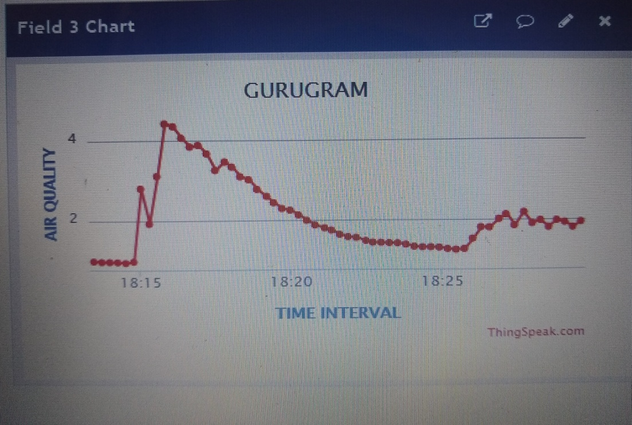

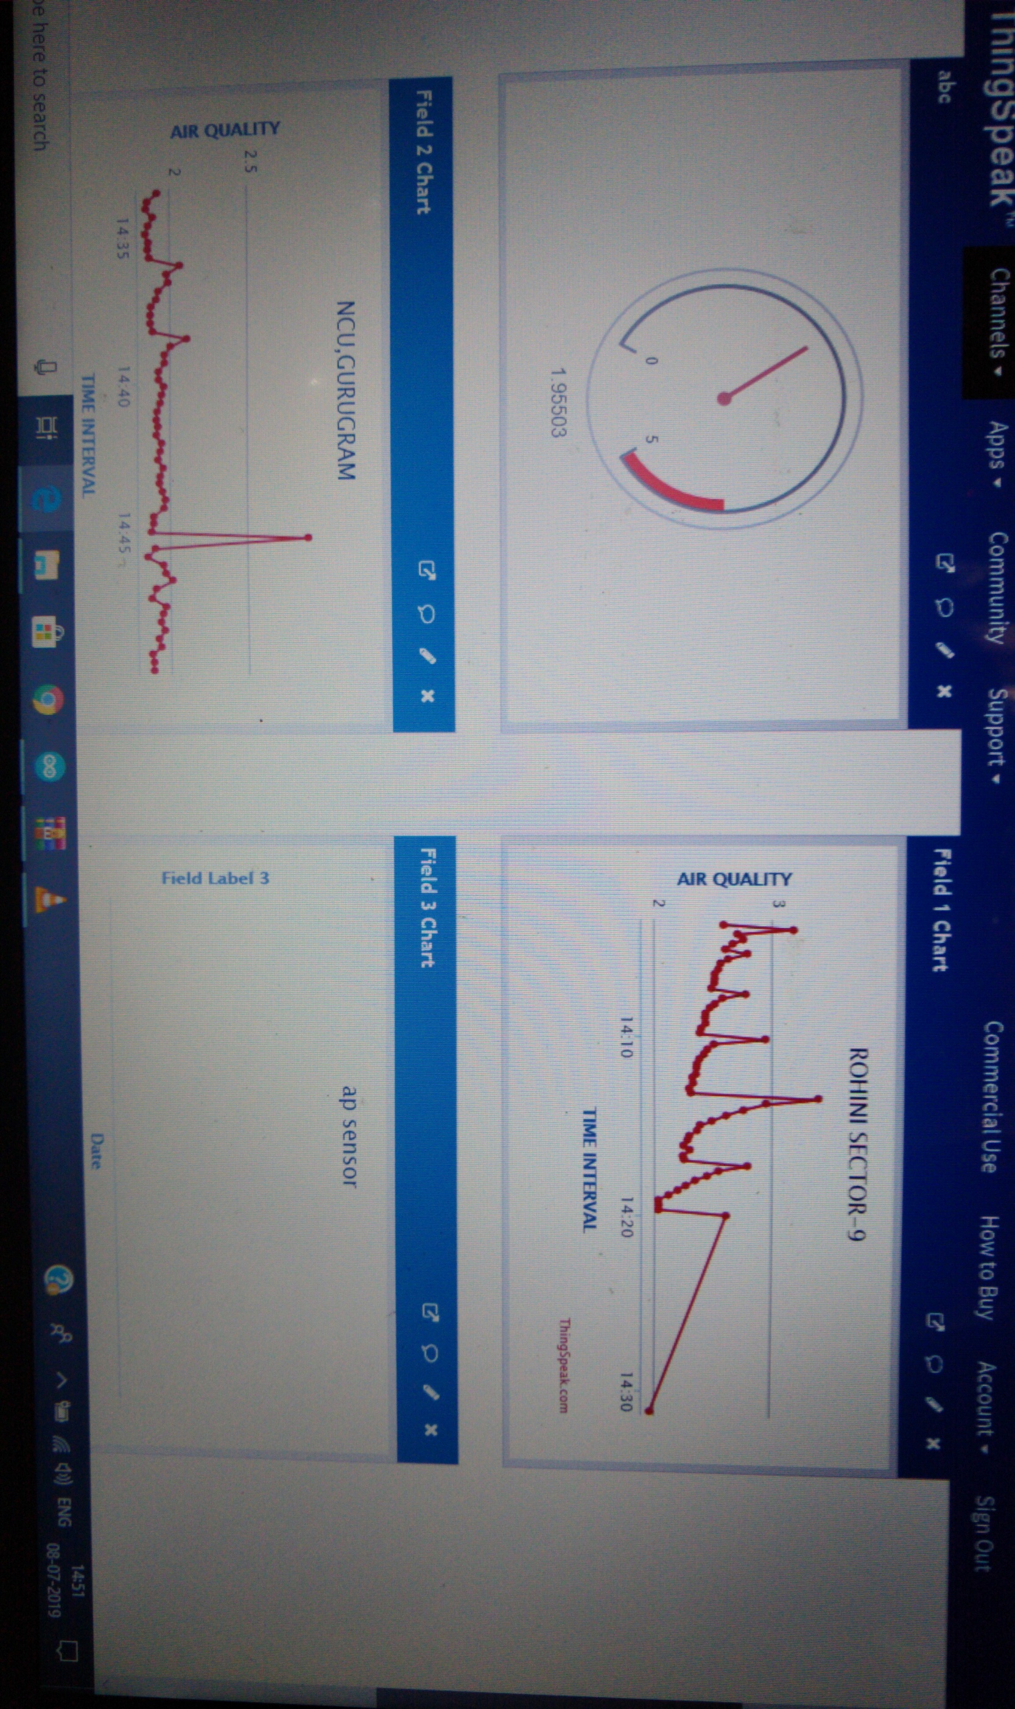

**DATA VISUALISATION ON ARDUINO OUTPUT**

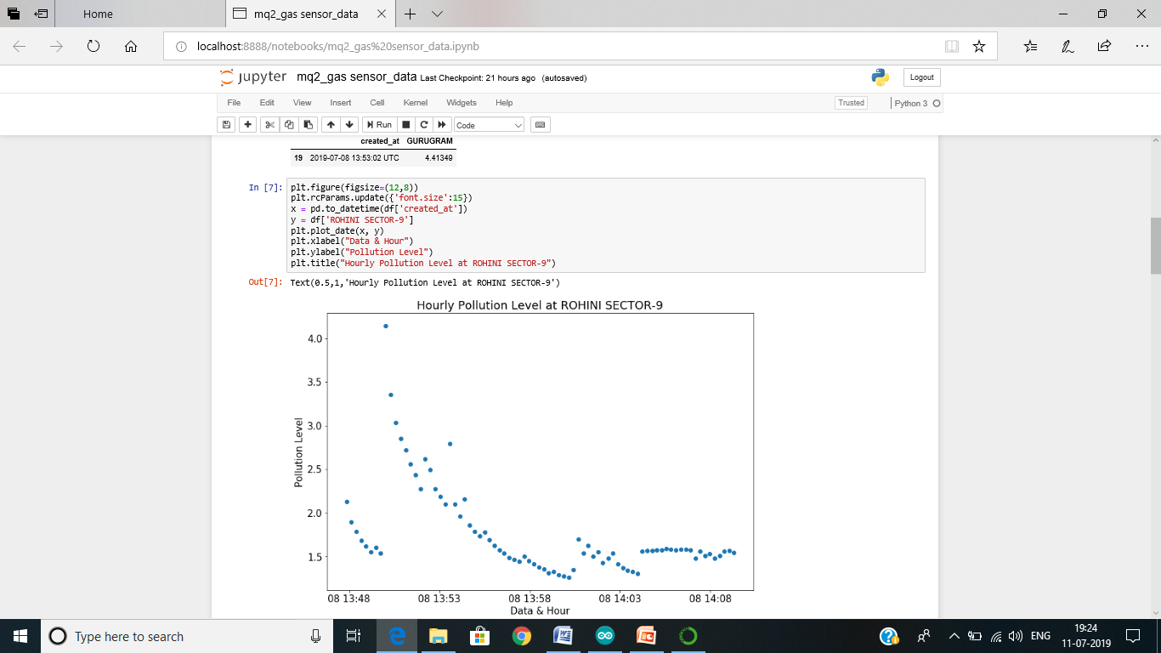

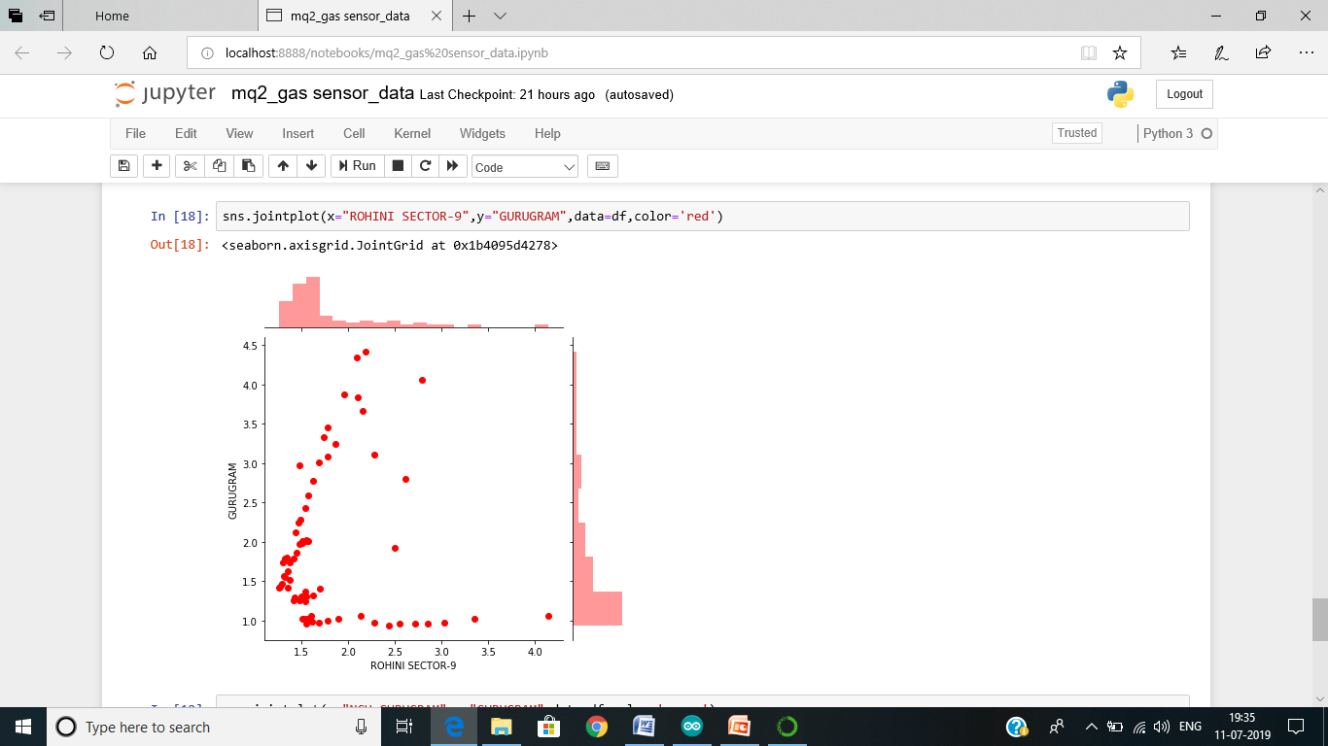

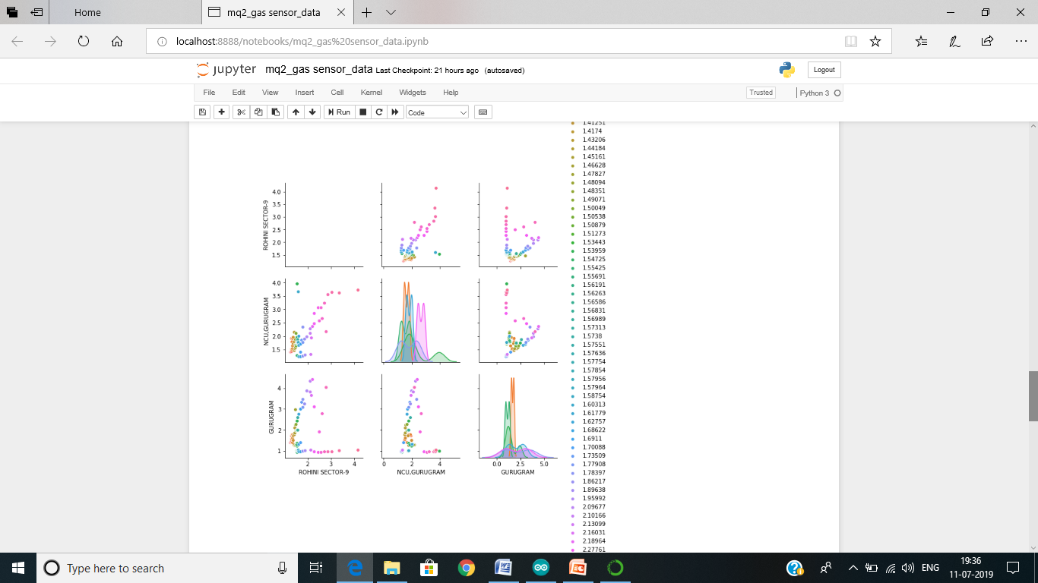

**CONCLUSION**

The system to monitor the air of environment using Arduino microcontroller, IOT Technology is proposed to improve quality of air. With the use of IOT technology enhances the process of monitoring various aspects of environment such as air quality monitoring issue proposed in this paper. Here, using the MQ6 gas sensor gives the sense of different types of dangerous gas and arduino is the heart of this project.